**TRADING VISION PROJECT- TVP**

**D0160 - USER-INTERFACE DESIGN**

.

.

.

.

.

.

.

.

.

.

.

.

.

.

.

.

|  |  |
| --- | --- |
| **Version:** | 1.0 |
| **Status:** | Approved |
| **Approver:** | Ngô Thái Bình  Nguyễn Thị Diễm Trang |
| **Author:** | Nguyễn Bảo Nguyên  Quách Hoàng Minh  Nguyễn Vũ Anh Thư  Ngô Gia Hân |



**Document History**

|  |  |  |  |  |
| --- | --- | --- | --- | --- |
| Version | Date | Author | Status | Comments |
| 1.0 | 16/01/2022 | Nguyễn Bảo Nguyên  Quách Hoàng Minh  Ngô Gia Hân  Nguyễn Vũ Anh Thư | Draft | Outlined main document sections and overview of screens. |
|  |  |  |  |  |

**References**

|  |  |  |  |
| --- | --- | --- | --- |
| Reference | Title | Author | Version |
|  |  |  |  |

**Table of Contents**

1. Introduction 4

1.1. Target Audience 4

1.2. Delimitation 4

2. Page Layouts 4

2.1. Header 5

2.2. Footer 5

2.3. Login form 6

2.4. Homepage 7

2.5. Search Index 8

2.6. Favourite List 9

2.7. View Specific Stock 12

2.7.1. Stock’s Information 12

2.7.2. View chart 14

2.8. Compare stocks 17

2.9. Reminder List 19

2.10. User Profile 23

2.10.1. Delete user 24

2.11. Page not found 25

# Introduction

The User-Interface Design documents the visual design of all pages on the **Trading Vision Project (TVP)**. The document also describes the components used for each page, as well as the structural layout and navigational flow.

## Target Audience

The purpose of this document is to describe and document the user interface for the solution.

The target audience is intended for developers, who are to implement the solution, as well as testers who are to test and approve the implemented solution.

## Delimitation

In this document, there is one main section describing the user interface of the Trading Vision Project: Page Layouts - Section 2. Page Layouts documents the different layouts used.

# Page Layouts

The following sections will describe the layouts used on the TVP.

## Header



Figure 1: Header

The Header template, which shows logo, search box, linked pages: Market, Favorite and Reminder. On the right, there exists user profile and notification.

## Footer



Figure 2: Footer

The Footer template, which will use the entire viewport width of the browser. It contains Contact, Quick Links and Follow Us columns.

## Login form

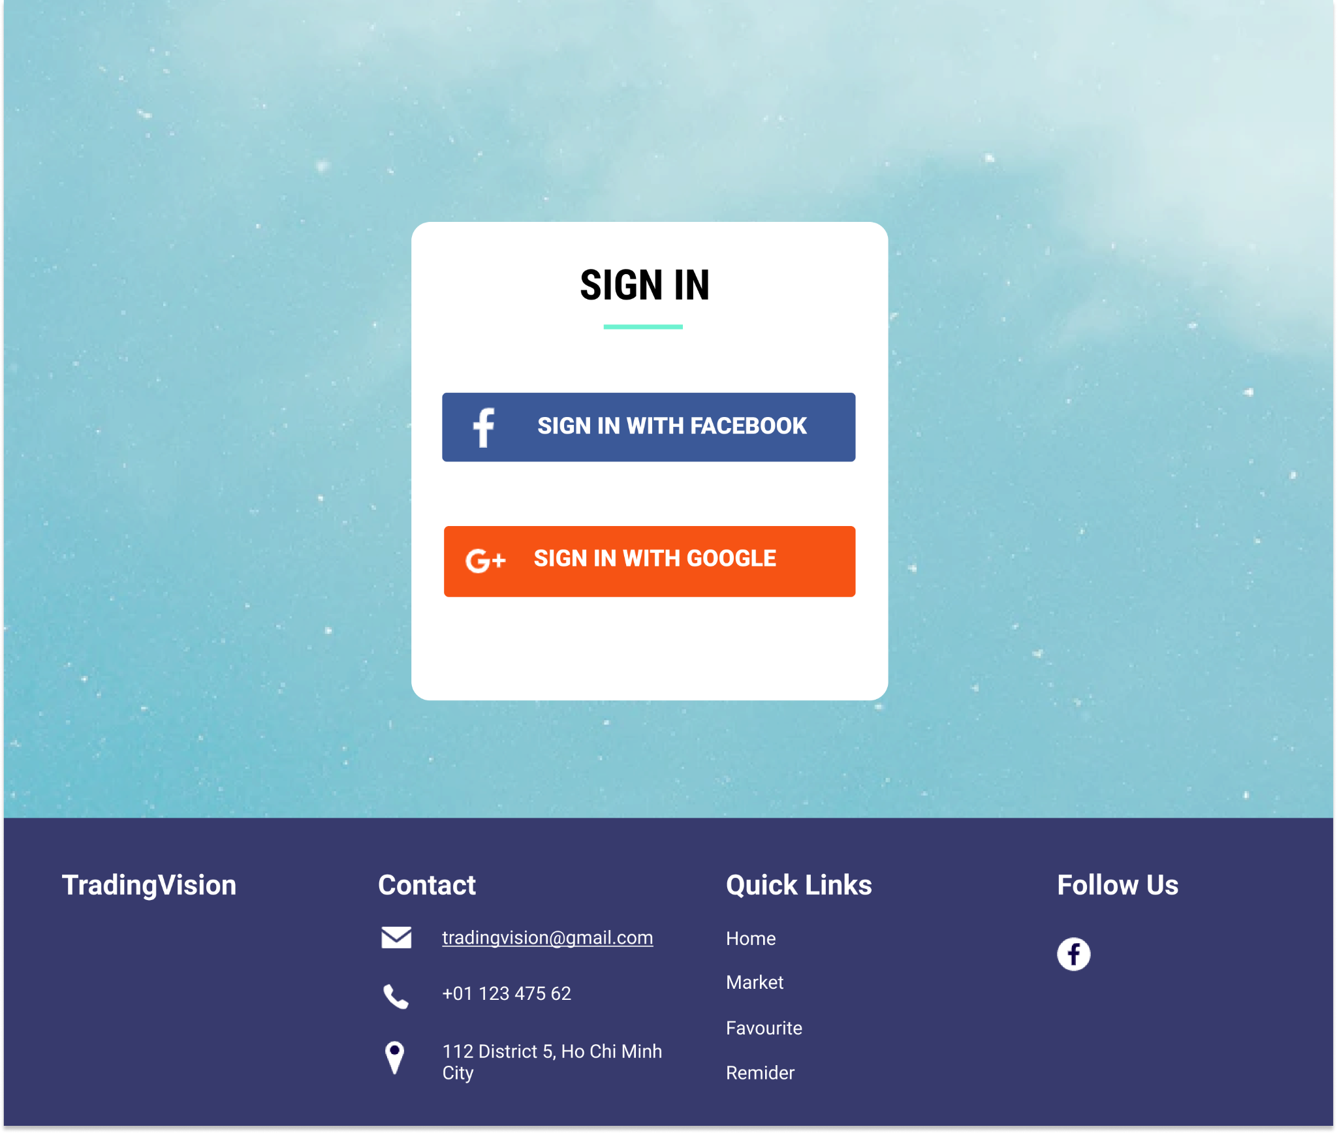

**2**

**1**

Figure 3: Login Page

|  |  |  |
| --- | --- | --- |
| Footnote | Component Name | Note |
| 1 | Sign In with Facebook | Login with Facebook account |
| 2 | Sign In with Google | Login with Google account |

## Homepage

**2**

Figure 4: Homepage

**1**

This is the homepage of the website; users can see the label and the company name including the chart of 5 stocks that are trending and have high volume on that day. The banner shows a wallpaper related to stock. We could search the index in the search bar on the header.

|  |  |  |
| --- | --- | --- |
| Footnote | Component Name | Note |
| 1 | Top list | Display the top 5 stock with highest volume |
| 2 | Search Index | There is a search function on the top right for the user to input the name of the index that they want to find. |

## 

## Search Index

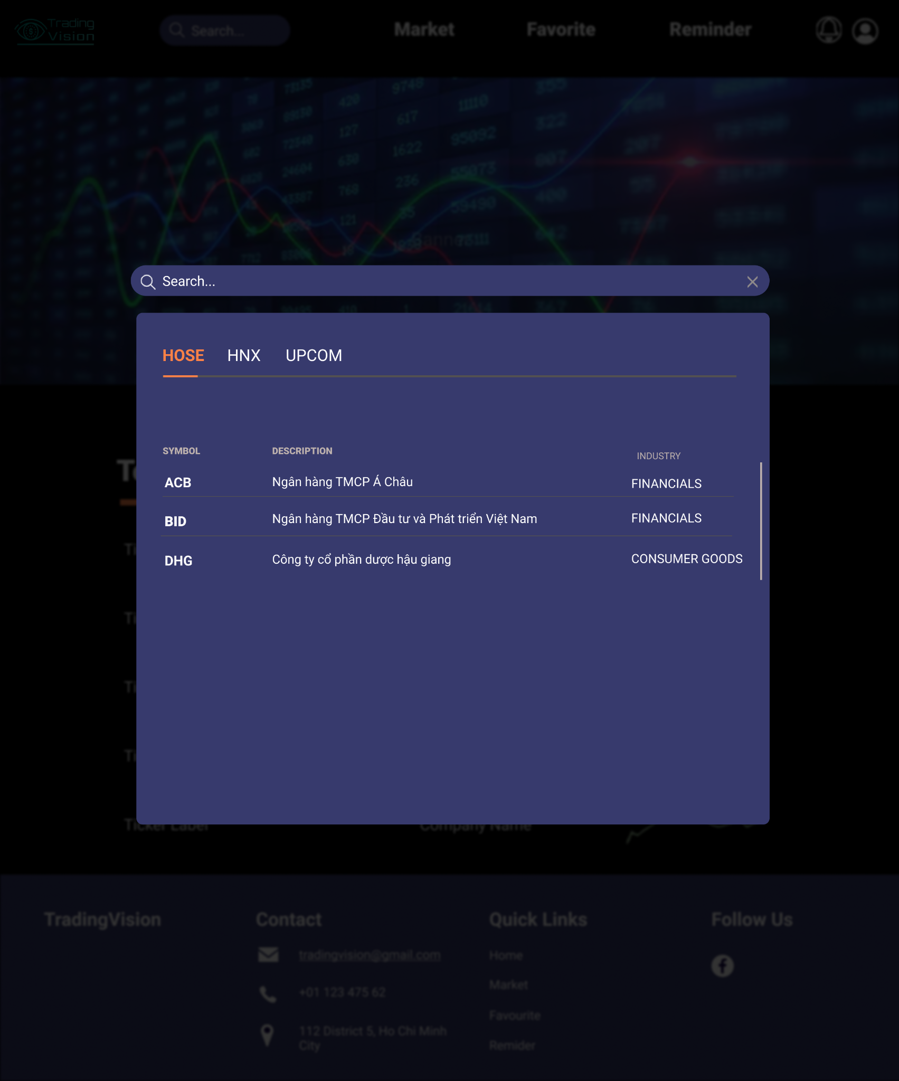

**2**

**1**

**3**

Figure 5: Search Index

When users click on the search bar, a popup will be displayed. Users can see all stocks belonging to each stock exchange or can write exact stock symbols to find. All stocks are always displayed in alphabetical order.

|  |  |  |
| --- | --- | --- |
| Footnote | Component Name | Note |
| 1 | Search bar | Let user input appropriate stock ticker |
| 2 | Stock exchange | There are three stock exchanges: HOSE, HNX, UPCOM. Clicking on each item displays the stocks in that stock exchange. |
| 3 | Stocks list | Clicking on each ticker will lead to a specific stock page. |

## Favourite List

In case, user does not have any favorite stock, there is a message “**There is nothing here. Please, add your favorite stock**”.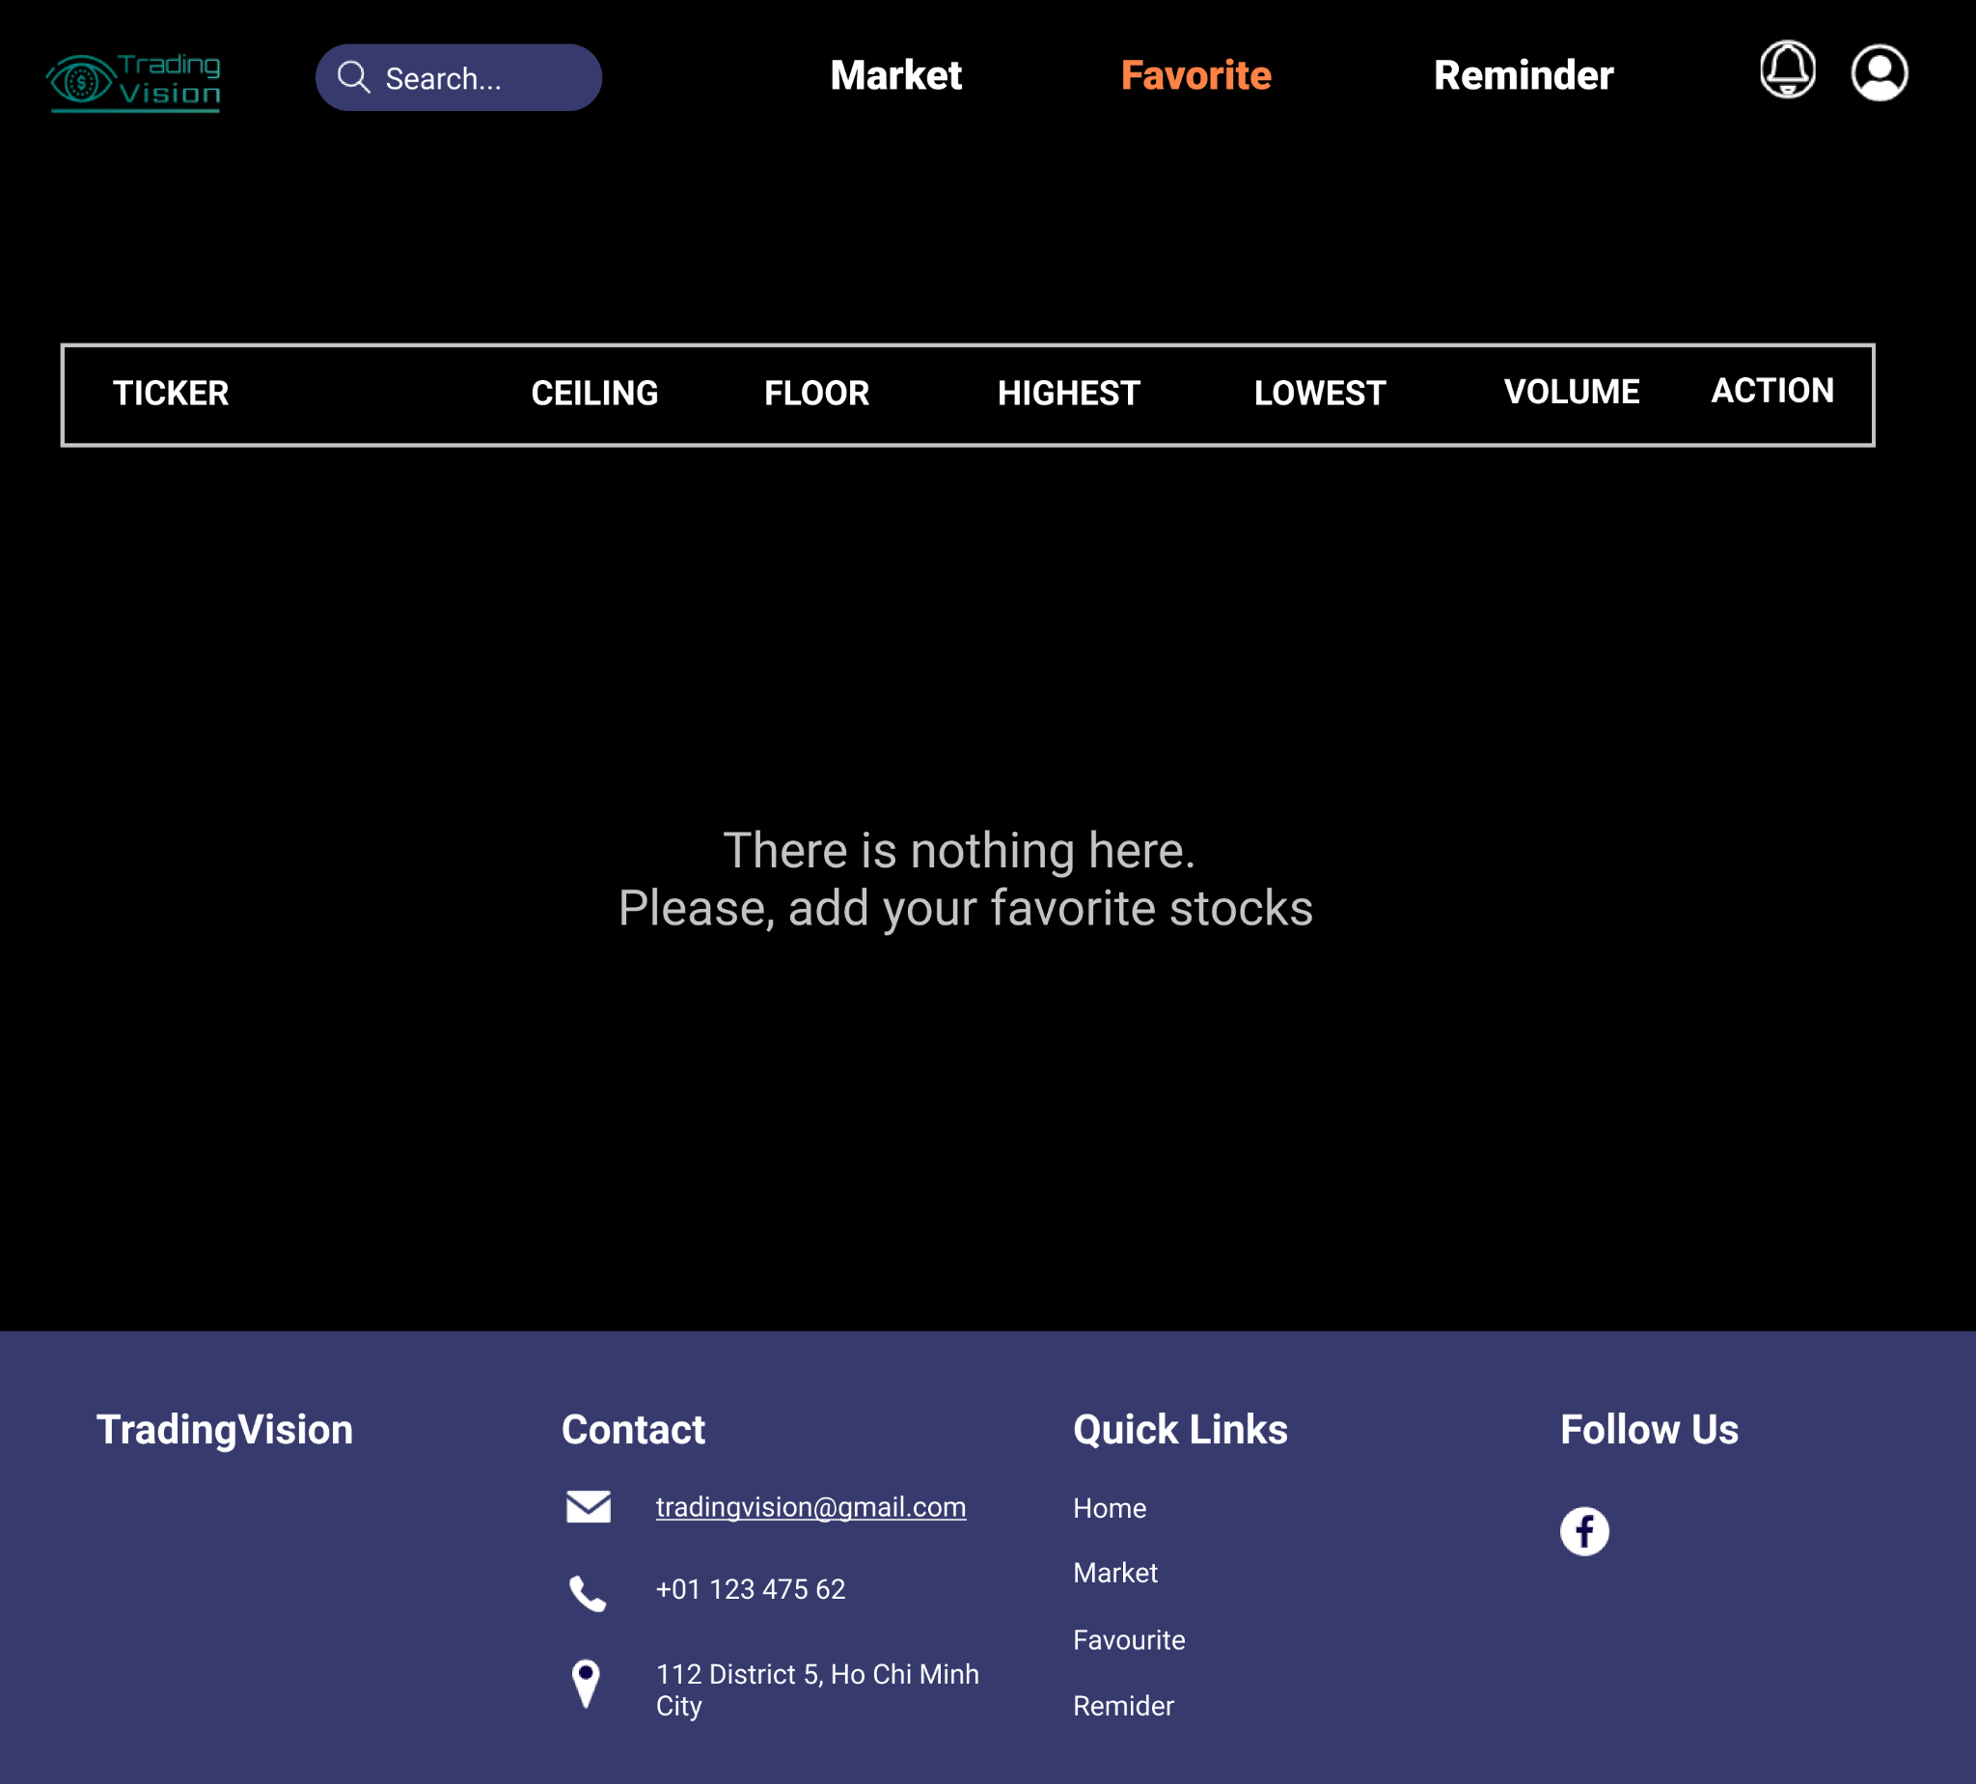

Figure 6: There is no stock in the favorite list

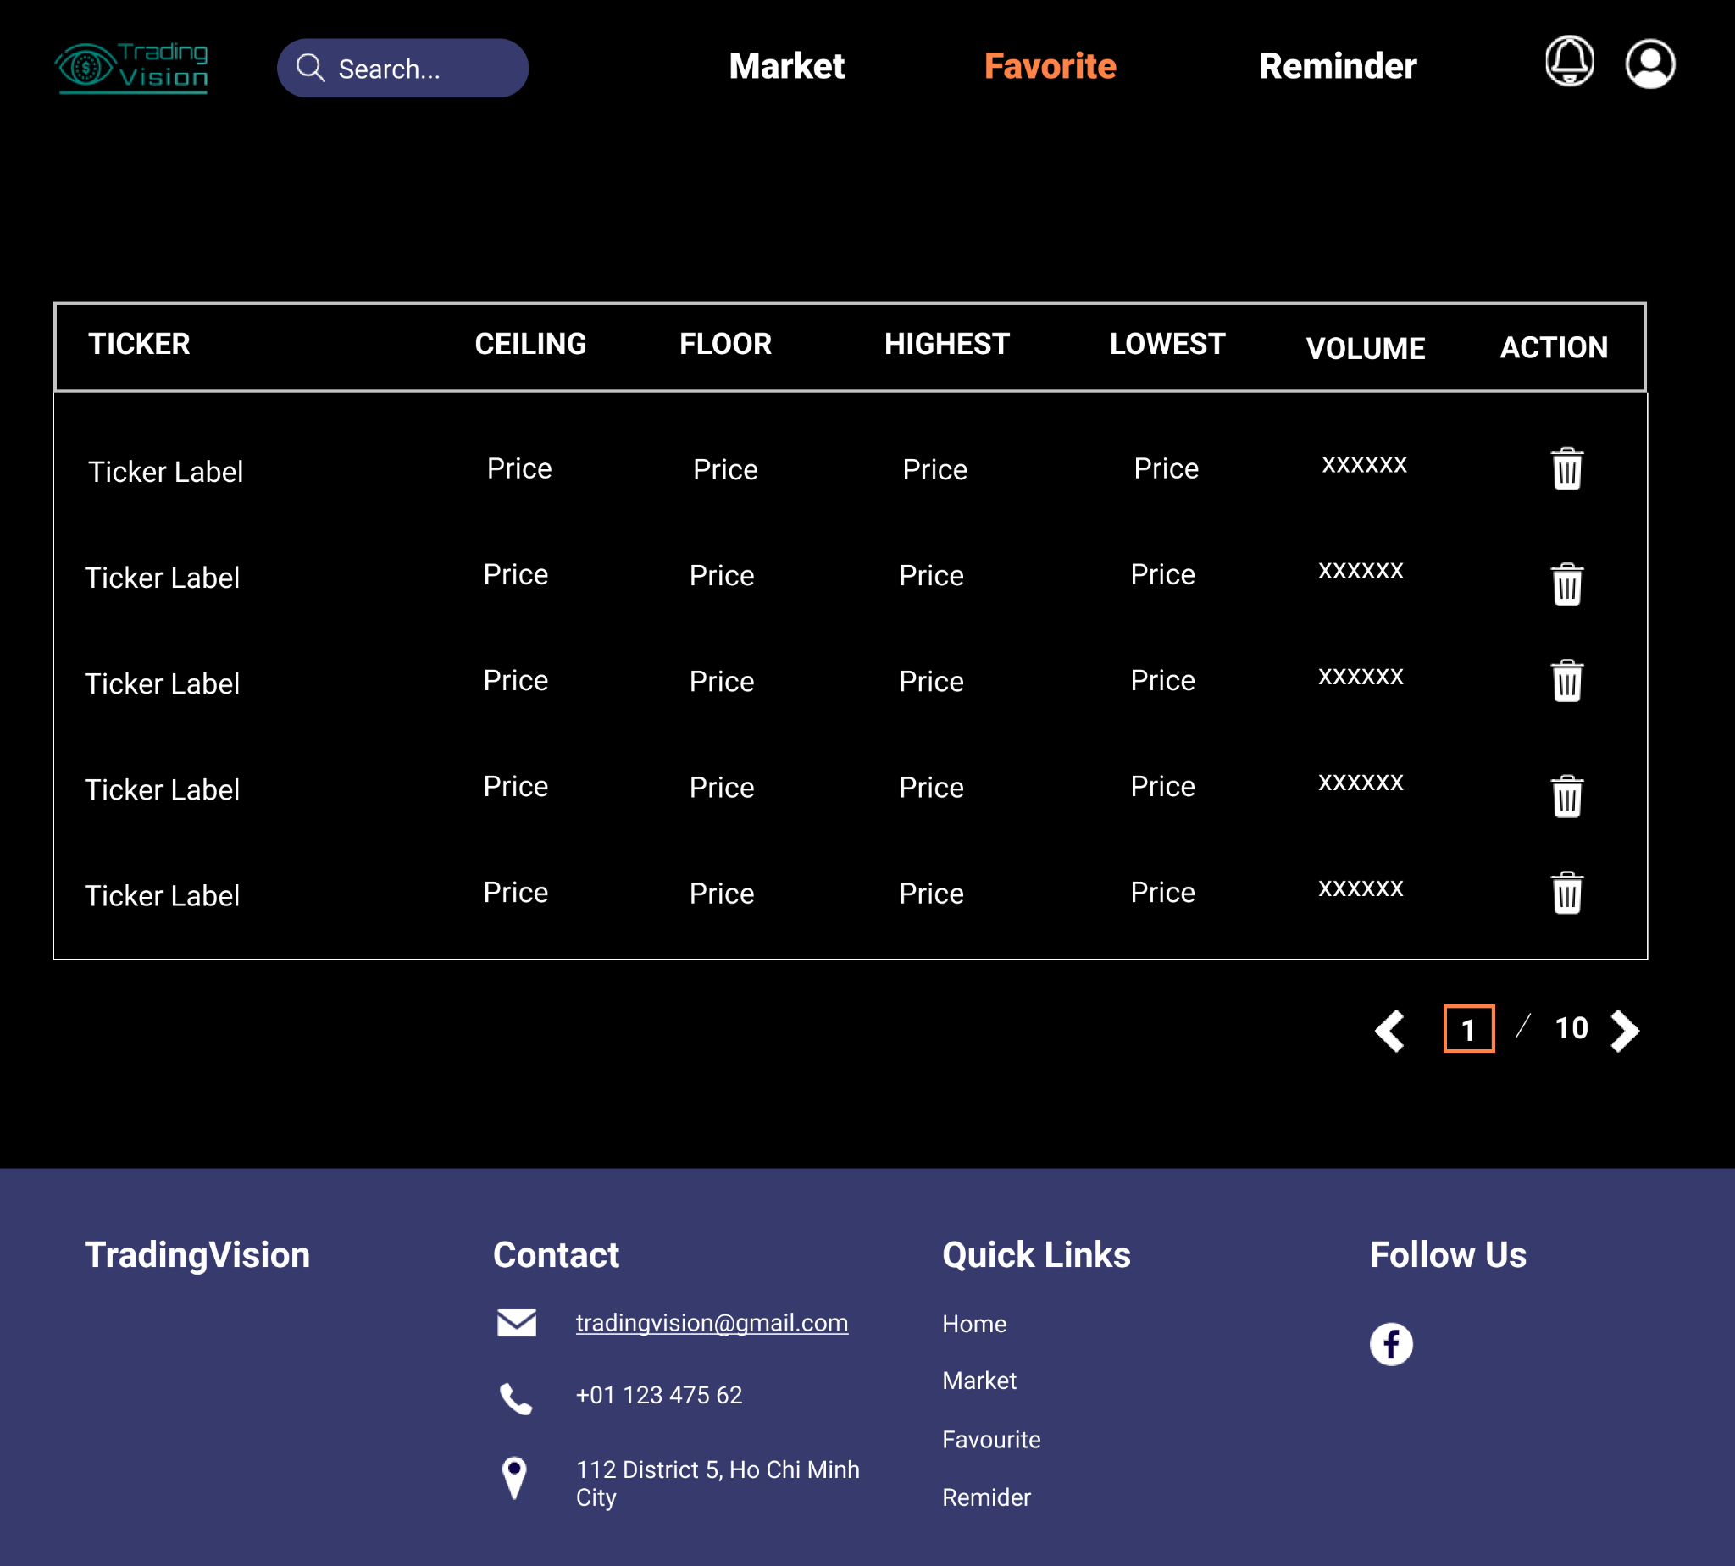

**2**

**1**

Figure 7: Favorite Stocks List

|  |  |  |
| --- | --- | --- |
| Footnote | Component Name | Note |
| 1 | Favorite stocks list | Clicking on the stock ticker will lead to a specific stock page.  In order to remove a stock from the favorite list, click on the “**Bin**” button. |
| 2 | Page button | Clicking on the arrow icon to switch pages |

The favorite page, this page displays all the stock, which the user follows. It will have the search bar for searching the stock favorite and the information of all the stock users added to this list. These stocks also show the information including ceiling price, floor price, highest price, lowest price, volume.

Users can click the “**Bin**” icon to remove a stock from the Favorite List. There is a pop up displayed.

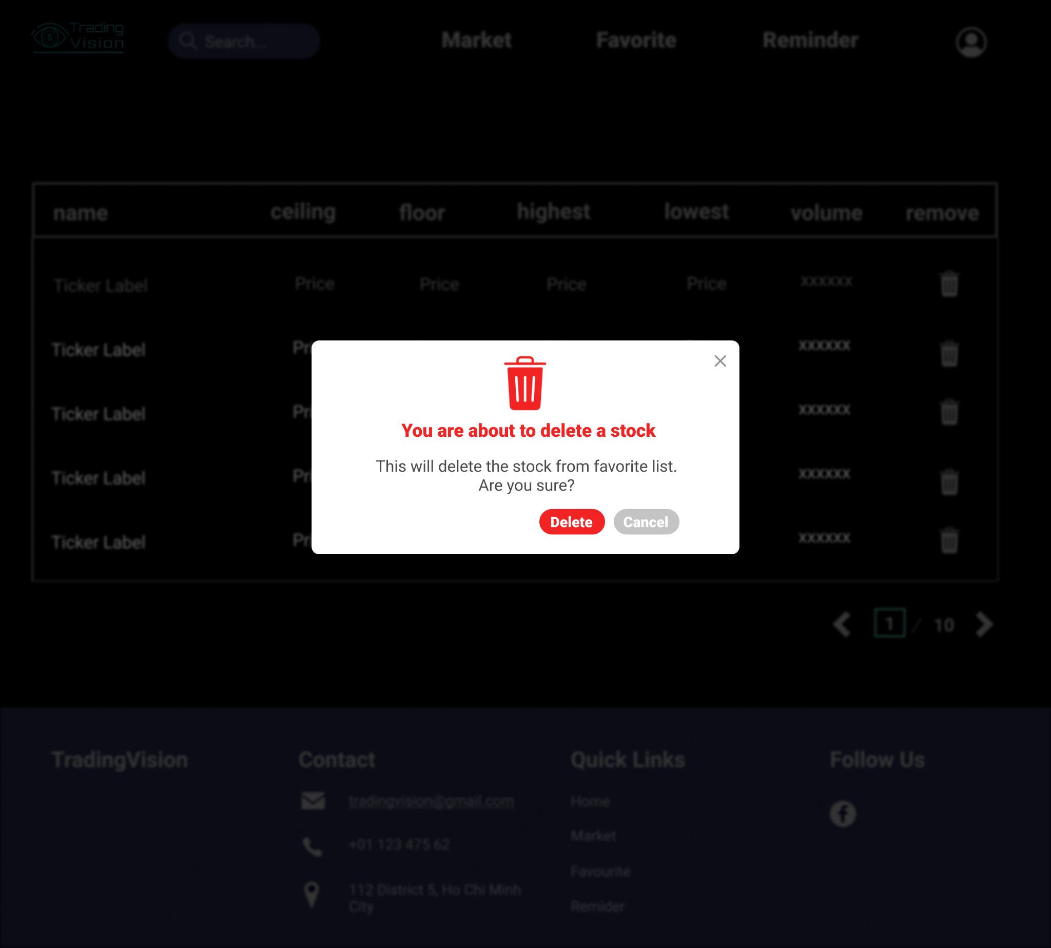

**1**

**2**

Figure 8: Delete favorite stock

|  |  |  |
| --- | --- | --- |
| Footnote | Component Name | Note |
| 1 | Delete button | Clicking on the **Delete** button, the chosen stock will be removed from the list.  Then back to the Favorite list page. |
| 2 | Cancel button | Clicking on the **Cancel** button, the popup will be closed. Users remain at the Favorite page. |

## View Specific Stock

### Stock’s Information

This is the stock detailed page, which will contain the stock’s sticker label and the detailed information of each stock. This will contain the name of the company, field, link to a webpage, a short description of the company, and some financial numbers.

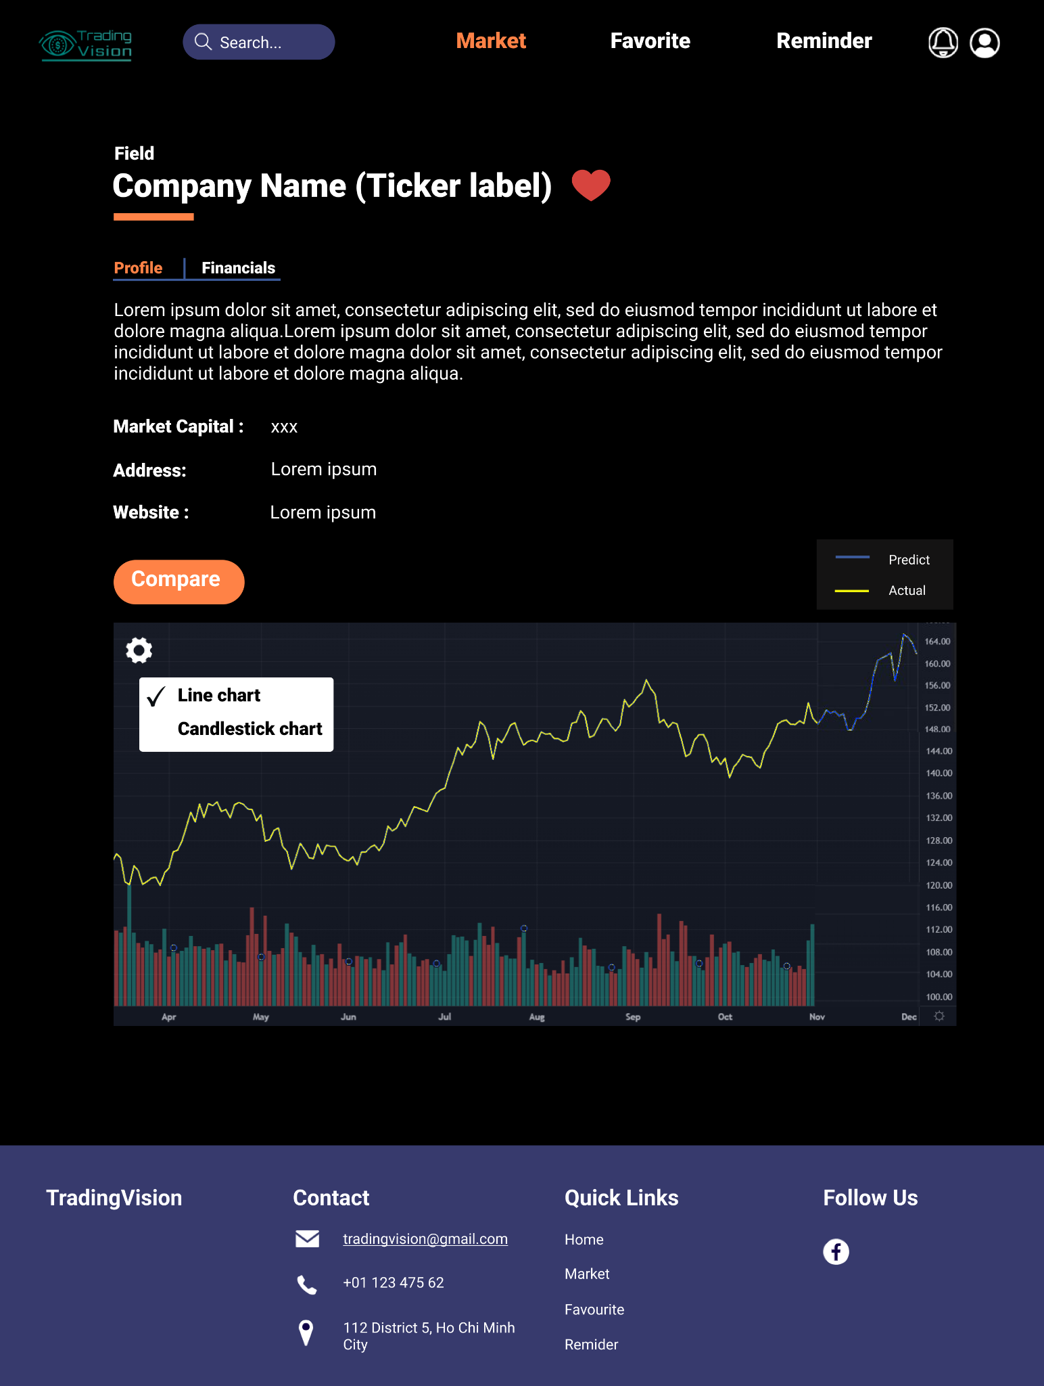

**2**

**1**

Figure 9: Company’s Profile

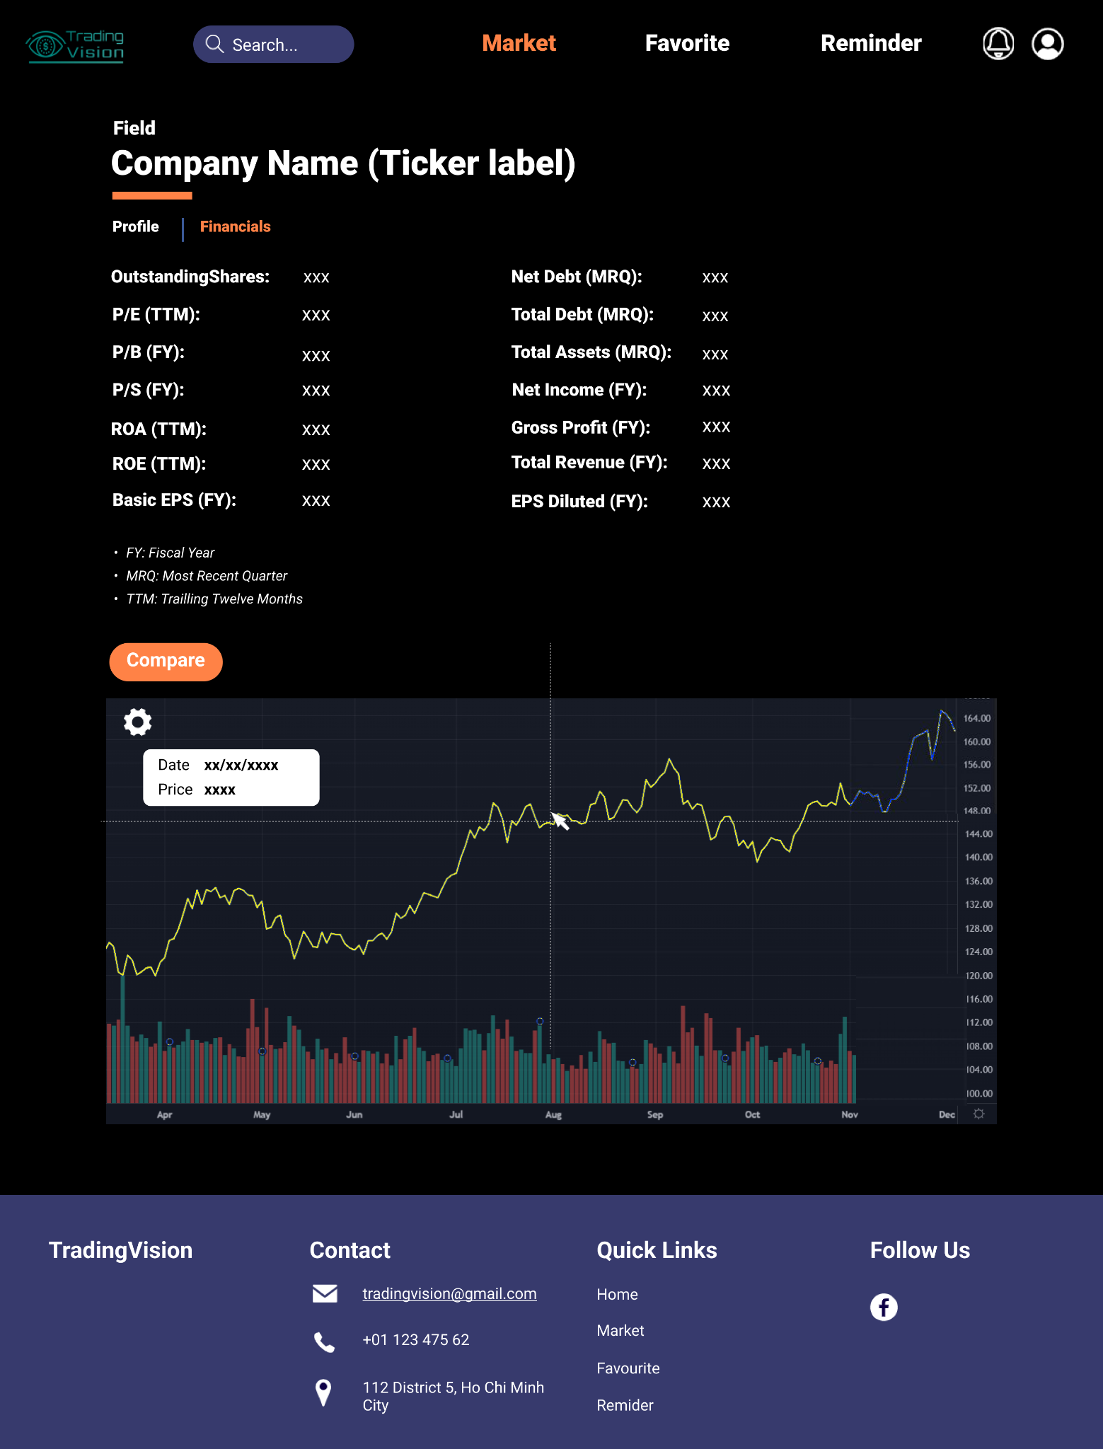

S

**2**

**1**

Figure 10: Company’s Financial Information

|  |  |  |
| --- | --- | --- |
| Footnote | Component Name | Note |
| 1, 2 | Company Info | In profile tab, there are:   * Full name and relating stock symbol of that company * Its address, brief information, market capitalization and website.   In financials tab, there are:   * Outstanding shares, P/E, P/B, P/S, ROA, ROE, Basic EPS, Net Debt, Total Debt, Total Assets, Net Income, Gross Profit, Total Revenue, EPS Diluted. |

### View chart

**1**

Figure 11: View stock charts

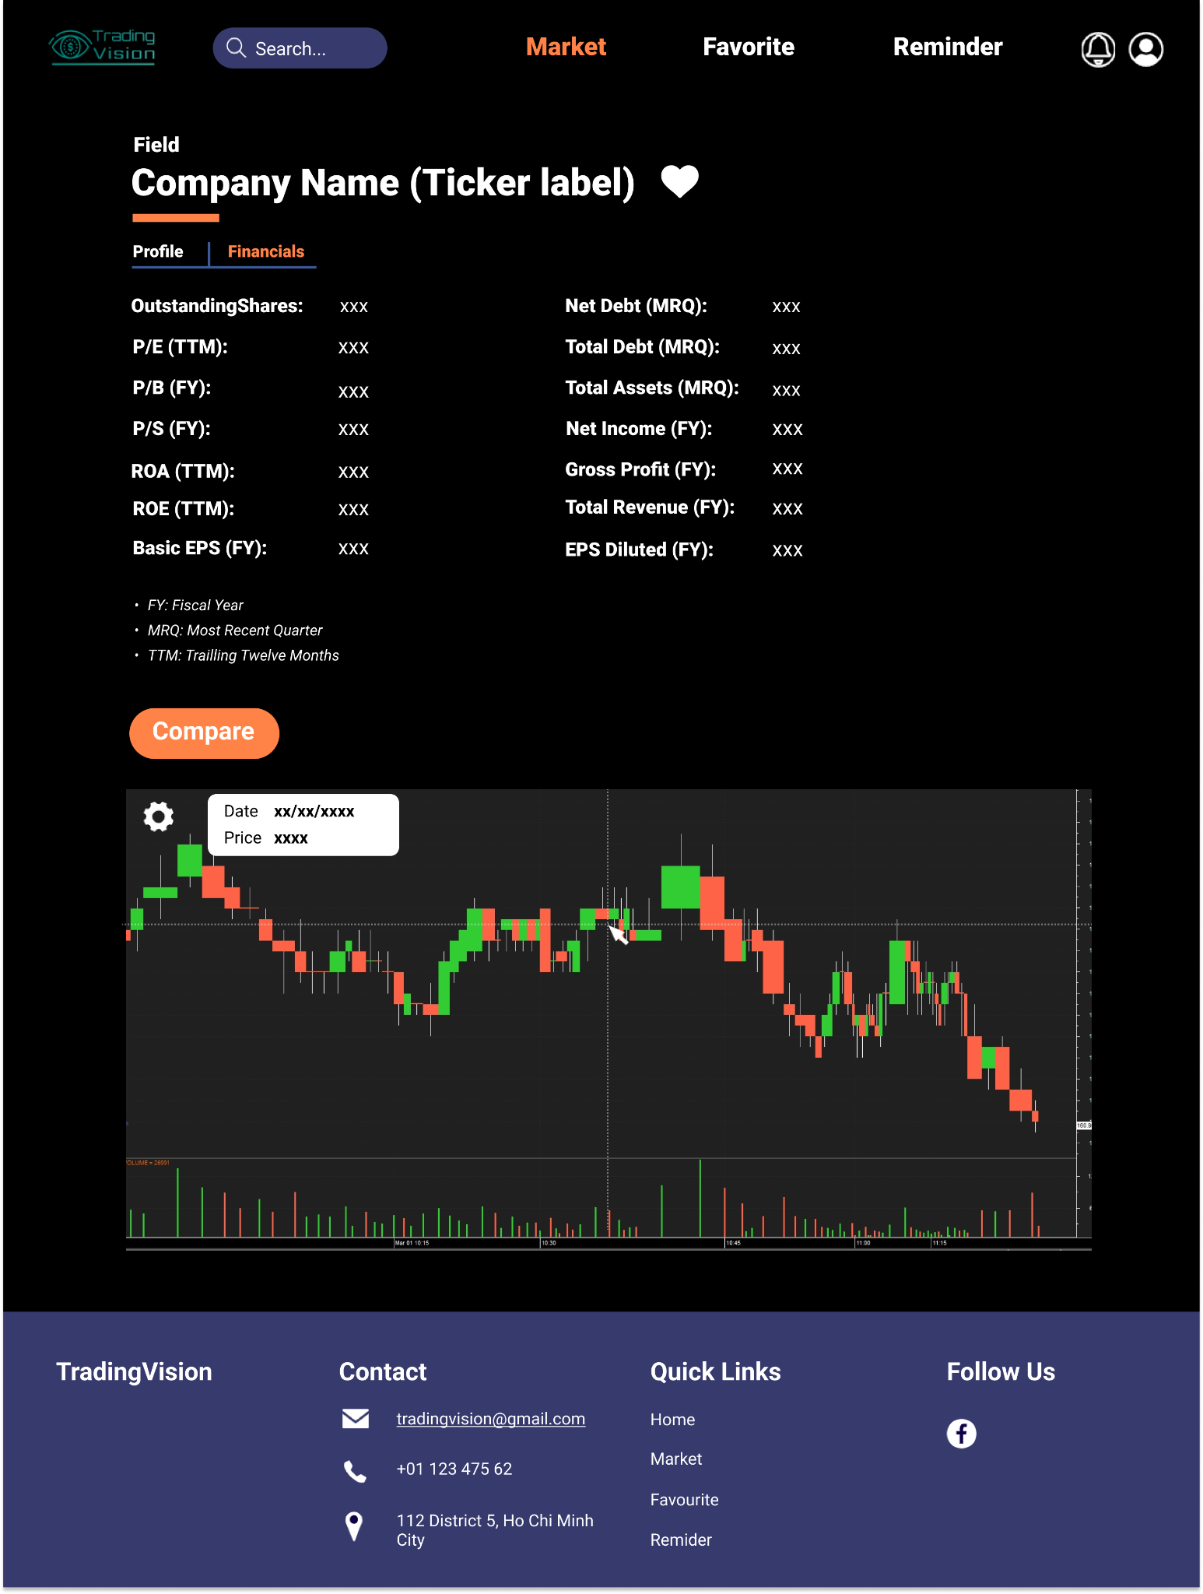

**2**

Figure 12: View candlestick chart

|  |  |  |
| --- | --- | --- |
| Footnote | Component Name | Note |
| 1 | Chart type | Choosing appropriate type of chart: candlestick chart and line chart with prediction line. |
| 2 | Price tag | Display price and date at a point on the chart when hovering over it. |

## Compare stocks

**1**

Figure 13: Compare between two stocks

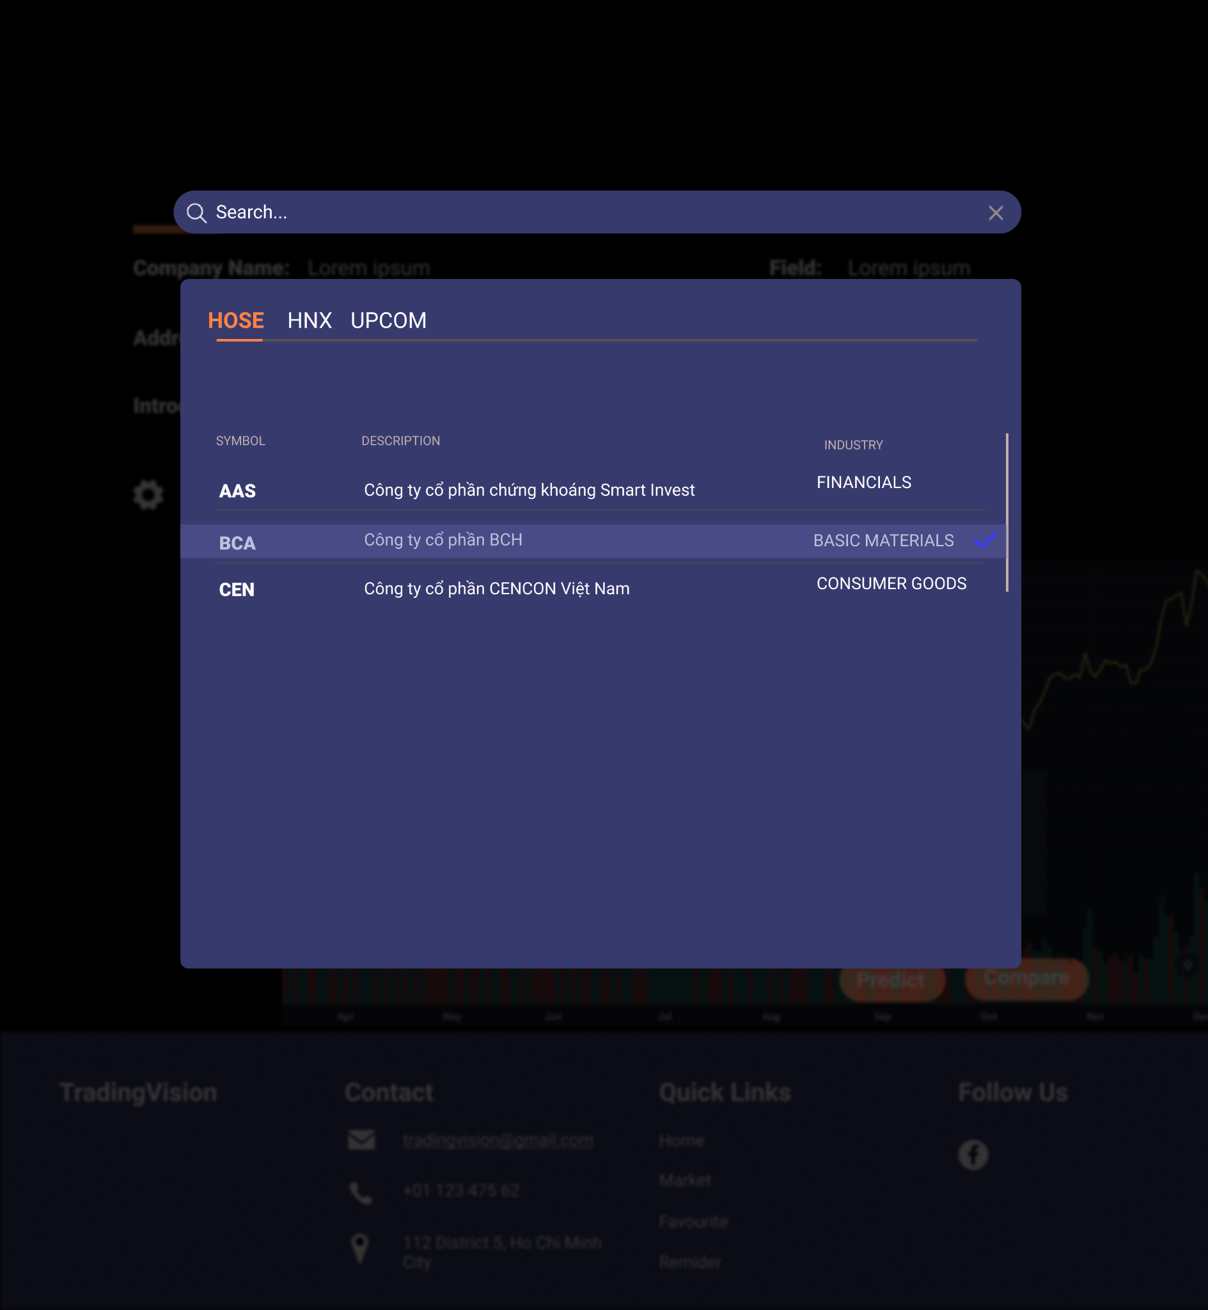

**2**

Figure 14: Choose appropriate stock to compare

|  |  |  |
| --- | --- | --- |
| Footnote | Component Name | Note |
| 1 | Compare button | A popup will be shown up. You can search like what you do in the search function. |
| 2 | Choose Index | Choose a stock label by clicking on it.  If you want to close the compare function, click the Compare button again, and choose the stock that you chose before one more time. |

## Reminder List

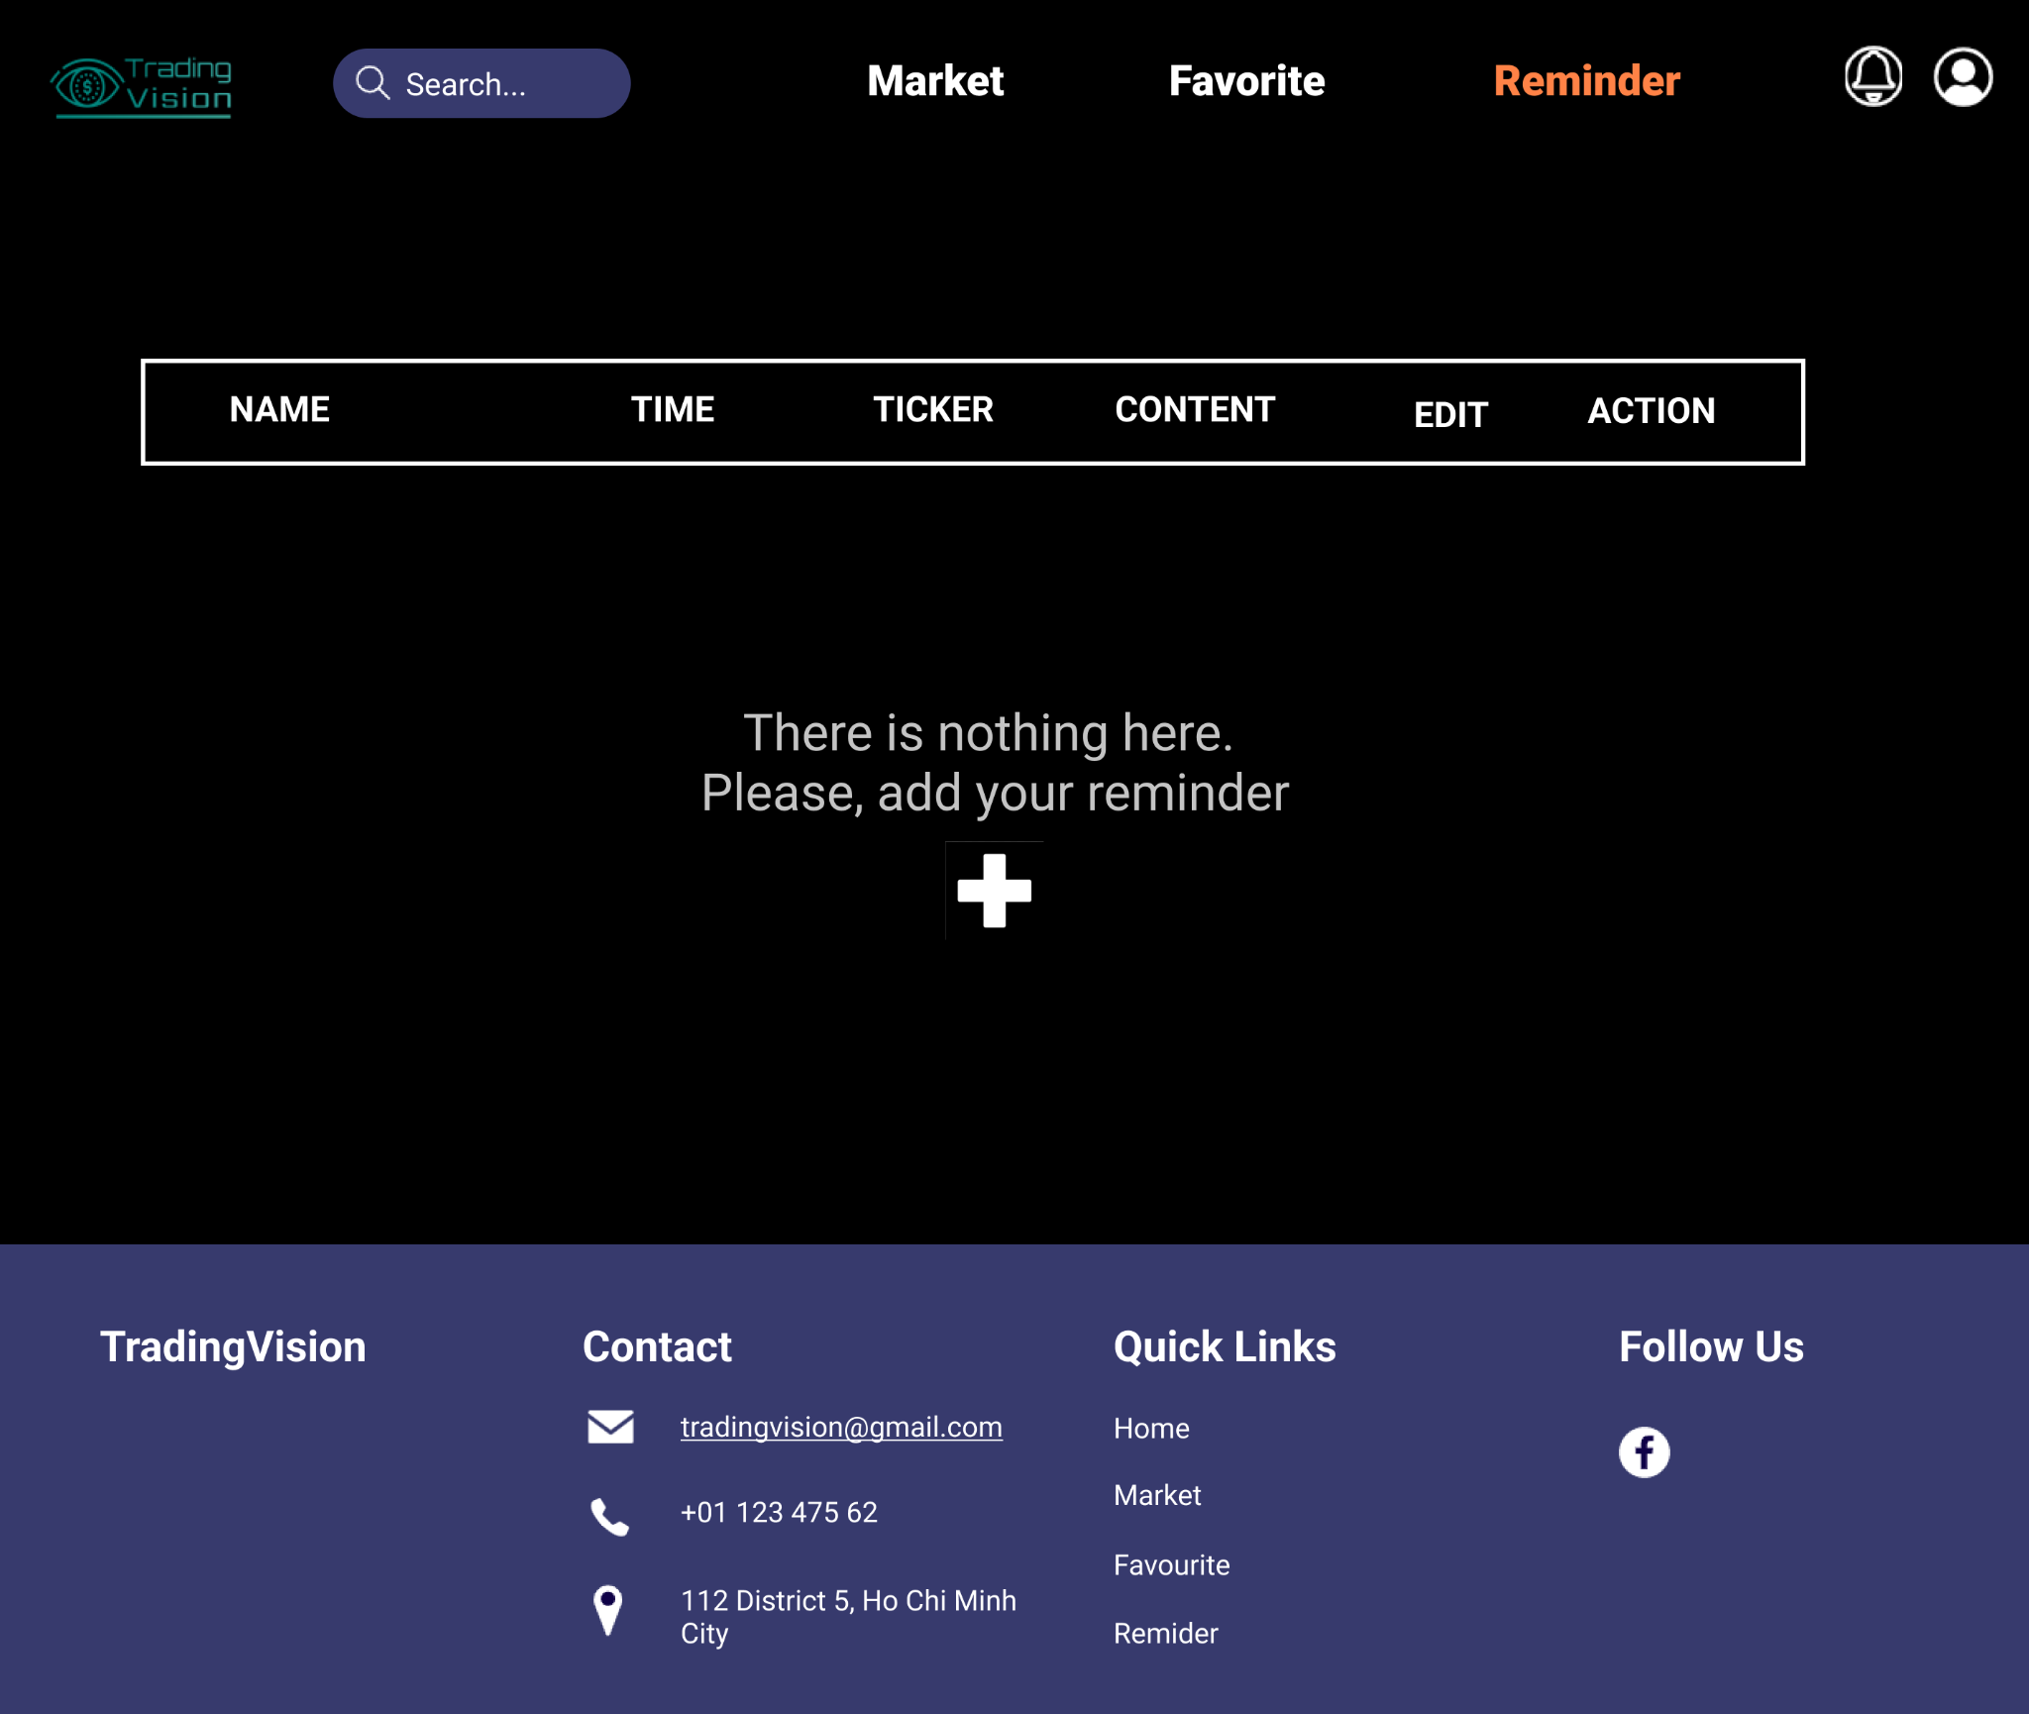

**1**

Figure 15: There is no reminder in reminder list

|  |  |  |
| --- | --- | --- |
| Footnote | Component Name | Note |
| 1 | Add button | When there is no reminder at the list, it will show this page.  Clicking on the “+” button to add a new reminder. |

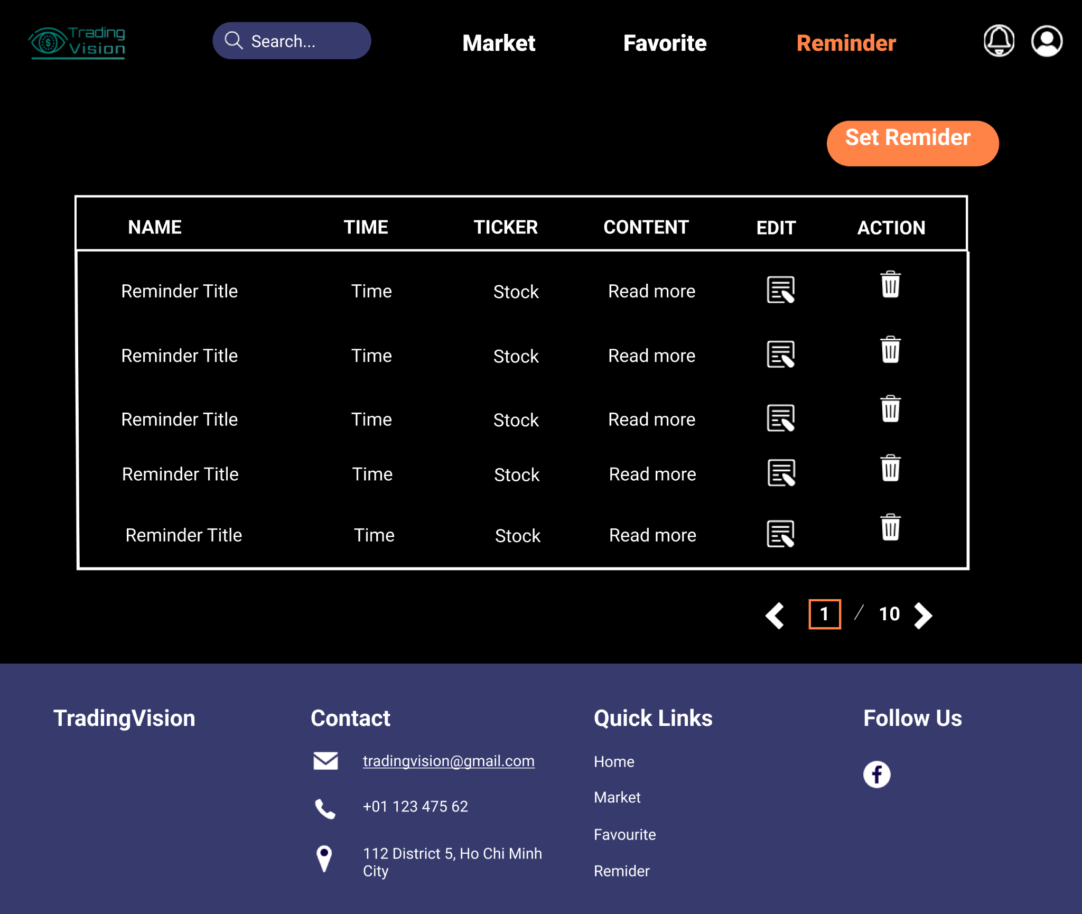

**1**

Figure 16: Reminder list

|  |  |  |
| --- | --- | --- |
| Footnote | Component Name | Note |
| 1 | Reminder list | Clicking on the reminder to read the full content of the reminder.  In order to remove a reminder from the reminder list, click on the “**Bin**” button. |

* + 1. **Add reminder** 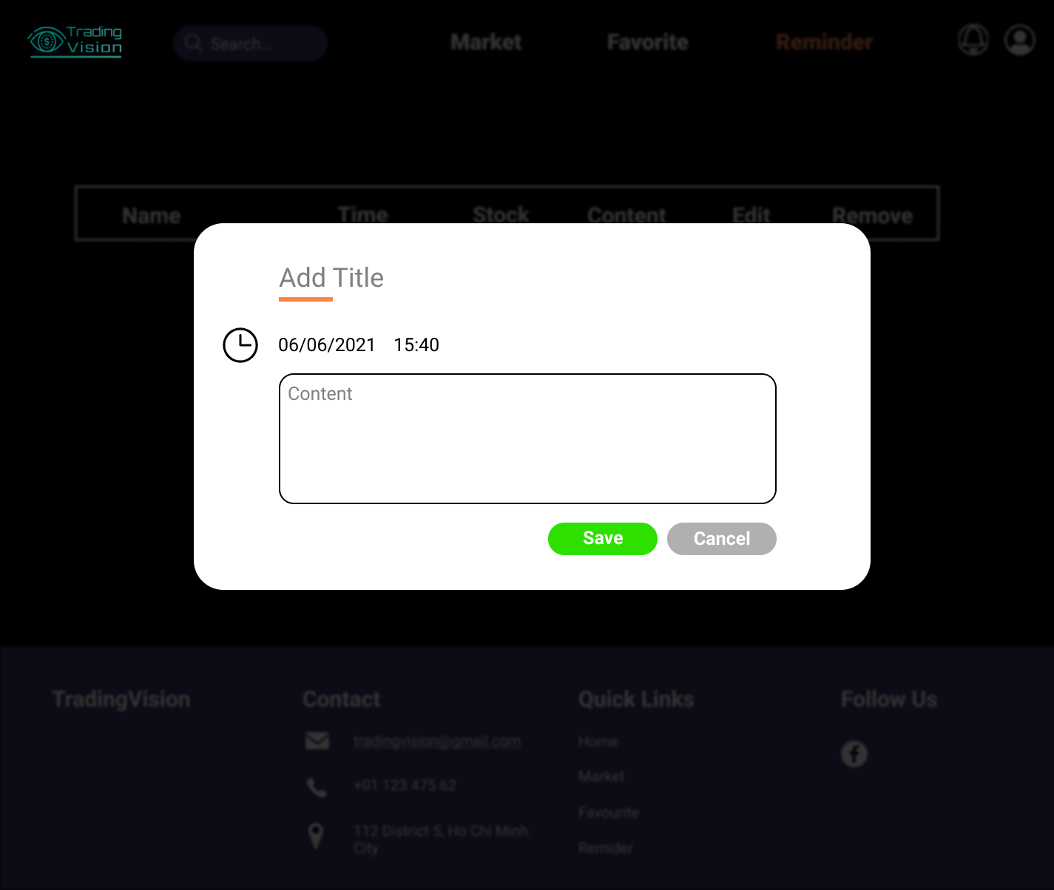

**2**

**4**

**3**

**1**

Figure 17: Add reminder

|  |  |  |
| --- | --- | --- |
| Footnote | Component Name | Note |
| 1 | Datetime | Users can set date and time appropriately |
| 2 | Content | Users fill the content they want. |
| 3 | Save button | Clicking on the **Save** button, the reminder will be added to the list.  Then back to the Reminder list page. |
| 4 | Cancel button | Clicking on the **Cancel** button, nothing will be saved to the list.  Then back to the Reminder list page. |

* + 1. **Delete reminder**

Figure 18: Confirm to delete a reminder

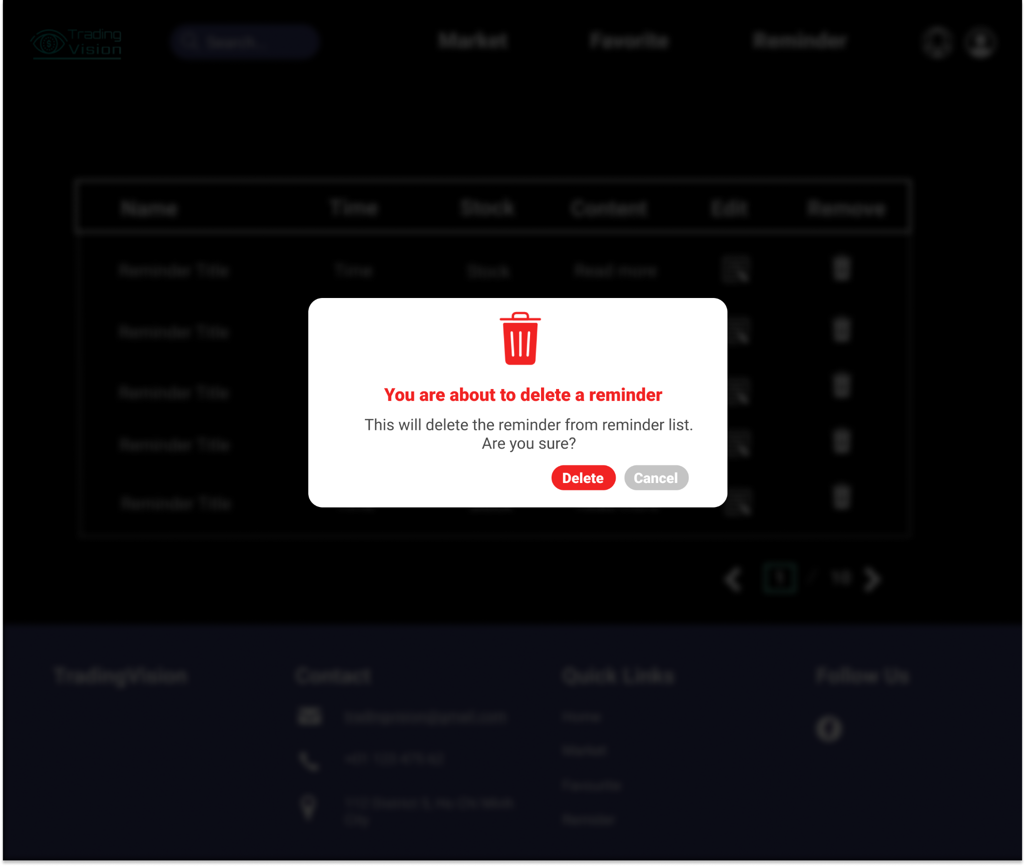

**2**

**1**

|  |  |  |
| --- | --- | --- |
| Footnote | Component Name | Note |
| 1 | Delete button | Clicking on the **Delete** button, the chosen reminder will be removed from the list.  Then back to the Reminder list page. |
| 2 | Cancel button | Clicking on the **Cancel** button, the popup will be closed. Users remain at the Reminder page. |

## User Profile

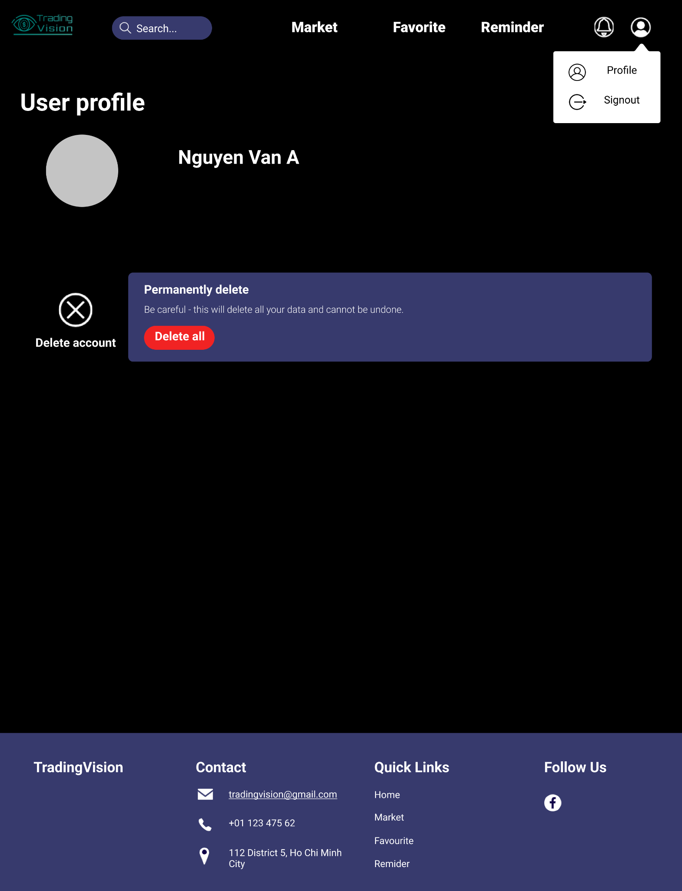

**3**

**2**

**1**

Figure 19: User information page

|  |  |  |
| --- | --- | --- |
| Footnote | Component Name | Note |
| 1 | User icon | Clicking on **User icon** to show the dropdown options. |
| 2 | Profile | Clicking on **Profile** option to open User Profile page. |
| 3 | Logout | Clicking on the **Logout** option, user’s account will be logged out and return to Homepage. |

### Delete user

**2**

**1**

Figure 20: Confirm to delete user account

|  |  |  |
| --- | --- | --- |
| Footnote | Component Name | Note |
| 1 | Delete button | Clicking on the **Delete** button, the information related to the users will be completely removed from the database. Users return to home page |
| 2 | Cancel button | Clicking on the **Cancel** button, the popup will be closed. Users remain at the User profile page.. |

### 

## Page not found

**1**

Figure 21: Error page

|  |  |  |
| --- | --- | --- |
| Footnote | Component Name | Note |
| 1 | Error page | Error page appears when it can’t load successfully |